**Task 12**

**Computer Network Lab**



**Submitted to Sir Rasikh Ali  
Submitted by Muhammad Ibtisam**

**Roll #: SU92-BSSEM-F22-288  
Section: SE-5B**

**Submitted on Dec 10th, 2024**

**DEPARTMENT OF SOFTWARE ENGINEERING  
SUPERIOR UNIVERSITY, LAHORE**

**Question:**

**VLAN:**

* Divides a physical network into multiple virtual networks.
* Each VLAN forms its own broadcast domain, isolating traffic.
* Operates at Layer 2 of the OSI model, dealing with MAC addresses.
* Devices in different VLANs cannot communicate directly.

**Example:**

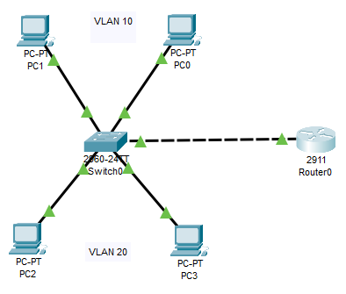

* Devices in VLAN 10 cannot communicate with devices in VLAN 20.

**Inter-VLAN:**

* Allows devices in different VLANs to communicate with each other.
* Requires a Layer 3 device (router or Layer 3 switch) to route traffic.
* Uses routing protocols like OSPF or RIP to establish routing between VLANs.
* Each VLAN is assigned an IP address, enabling routing between them.

**Example:**

